
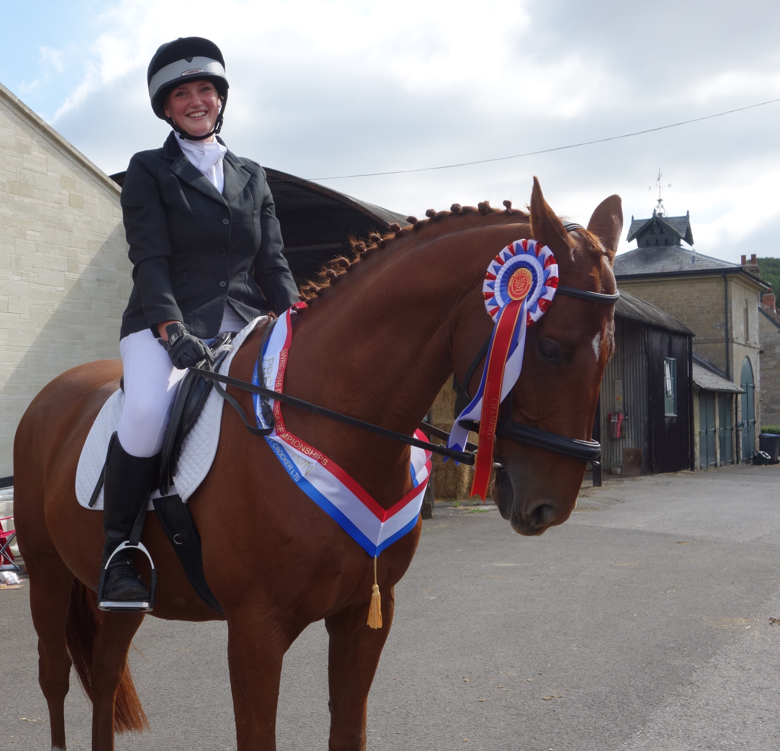
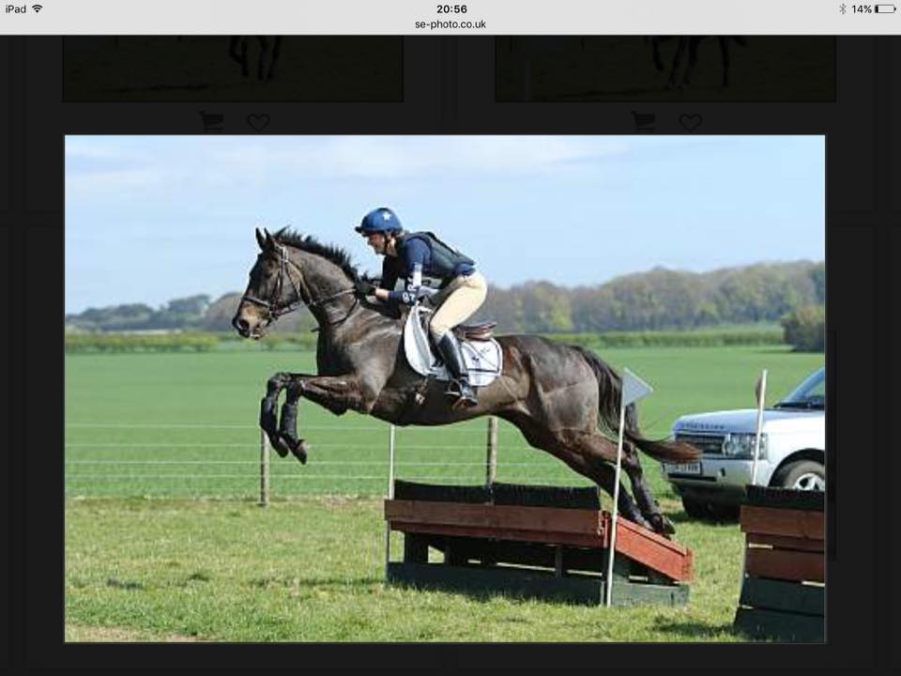
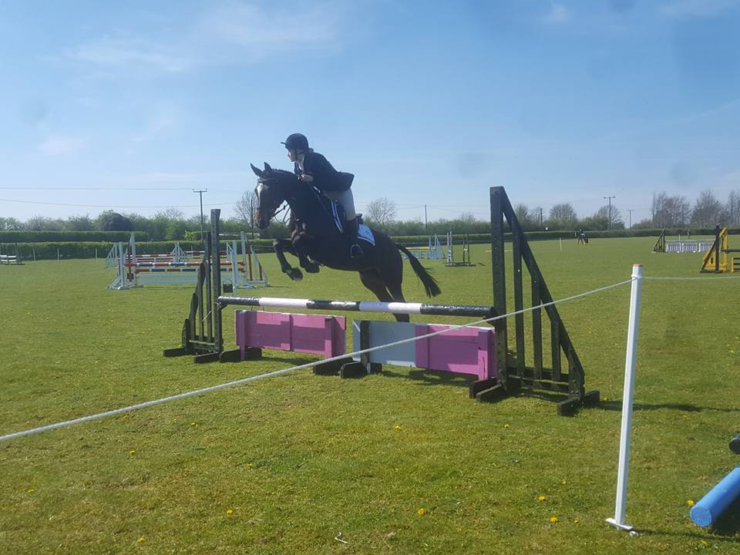
South Wiltshire Riding Club
You may be thinking that you don’t remember reading your Summer Newsletter – and you would be right! A bit like the actual season I have by passed summer and gone straight to Autumn. My procrastination knows no bounds it would seem but to be fair, as you will read later, as a club we have been very, very, busy.
It will never cease to amaze me how willing people are to give their time, expertise, help, cheerfulness and general all round eagerness to support something they love. Our club has built up a fantastic membership full of people like this and we would like to say a heartfelt ‘thank you’ to you all.
We must be doing something right as we now have over 100 members and that is the first time we have achieved this for as long as anyone can remember. We certainly feel ‘more the merrier’ and hope that everyone takes advantage of all that is on offer. Even though we have built up our membership we are still a small club and pride ourselves on our friendly and inclusive lessons and team spirit.
So, please read on to see what everyone has been doing over the summer and we hope to see you all at our AGM in January 2018. We have decided to change the date to coincide with Annual Membership Renewal and this way we hope you can attend the AGM and renew your membership at the same time.
Sheri

Autumn 2017
New Members
Welcome to new members who have joined since April . If you have not seen your name here and I have inadvertently missed you off, please let me know (Sheri) so you can be included in the next newsletter.
Laura Saxon, Lizzie Mackie, Jodie Haskell, Isabelle Morris, Kristina Beard, Colin Phillips, Joanne Phillips, Natalie Baird, Joanna Dale, Abby Bannell, Susie Smith, Sara Hewlett ( about time!), Georgia Lace Matthews, Elizabeth Gill, Janet Burnett, Alice Wigmore, Alison Whipp-Long, Fliss Turner
Below are a few pics of members out and about competing for the club and now that you have joined as members we hope that we can put your photo below!
www.southwiltsridingclub.org.uk

South Wiltshire Riding Club
Affiliated to the British Riding Club
Competition and Events News
The results of competitions as they happen are published on the Website and on FaceBook but here is a resume of this summer’s events and competitions. When you see how many there are you will understand why the newsletter is a little late! I have to admit that most of these write ups are from Sarah as she was at all of these competitions.
May 20th we had our Have a Go Dressage at Teffont which was a beautiful sunny day with a great turnout. This event is a great way for the more nervous rider or someone who is new to dressage to have a go at a test without the pressure of it being a real competition. They are given feedback by the judge after the first test and then able to ride it again with hopefully some improvement. Always helped by the fantastic catering that Jayne Parsons provides, cakes galore which always go very quickly!
May 20/21 was the BRC FOTH Championships held at Aston-Le-Walls. We entered Senior and Junior Teams who all thoroughly enjoyed the weekend bringing home a variety of ribbons. Lucy Watling and Cass had an individual 10th in the 85cm JNR Combined Training. The JNR 80 team consisting of Sorcha Goody, Lucy Watling, Kate Greenall and Chloe Haskell came 8th after some fabulous riding and a challenging XC. Sally Williams competed in the SNR 90 challenge and was just out of the placings with an unfortunate SJ pole and time penalties. The SNR 80 team Donna Boyd, Martine Kemmish, Ruth Dresman and Roy Southey came a very respectable 5th.
June 1st and July 6th was Evening Dressage at Teffont and Warminster. Again blessed with good weather there was a good turnout of competitors and everyone that was placed 1 – 6 were then invited to the dressage championship show in September.
June 18th Horse Trials Qualifier at Moreton. Winning once as a team is amazing, winning twice is unbelievable but winning 3 times is incredible!! That is how sarah Mitchell-Sheppard summed up the day at Moreton. In sweltering temperatures the horses and riders kept their cool and performed magnificently. Win number one was for the JNR 80 team – with an individual 3rd for Ben Burgess, 7th for Lucy Watling and 8th for Sorcha Goody.
Win number 2 for the senior red team with individual 1st for Donna Boyd, 3rd for Sarah M-S and 5th for Roy Southey.
Win number 3 for the SNR 90 team with individual 1st for Di Burgess, 5th for Donna and Sally Wlliams and 6th for Alice Stone.
2nd place for the SNR White team and individual 3rd for Jesse Gibbons
Individual 4th for Sarah M-S and 5th Martine Kemmish in blue team.
Also a big well done to Zoe Dunham in the 100 as an individual but unfortunately not quite in the ribbons.
July 9th SWRC hosted the BRC Area 17 SJ and Style Qualifiers at Bovington. This was a huge undertaking for the club and involved so many members either helping or competing but was a successful day with many lessons learnt. Everyone worked so hard on yet another swelteringly hot day. Apart from hosting a great event we also managed to have a JNR 70 and 80 team qualify for the Championships in September.
July 15th SWRC Novelty Show at Teffont. As usual this was a day of great fun and laughter. So many entries from young and old for the dressage and gymkhana! Such a busy day but all worthwhile to see so many people enjoying themselves.
July 23rd BRC Area 17 Dressage at Hurn, Christchurch. 3 lovely tests from our individuals – Karenlee Barrett stepping up to Novice and Jo and Colin Phillips making their debut appearance representing the club. Unfortunately no placings but plenty of smiles and things to go away and work on.A team 3rd for Tom Dyer, Tara Goree, Sarah M-S + Sally Shepherd with a fab individual 2nd for Tom Dyer on new ride Louie and 3rd for Tara Goree and Duchess.
A team 5th for Martine Kemmish, Tom, Daisy Weir and Karenlee.
Team 4th and 5th for juniors with individual 4ths for Abi Goree, Ellie Portnell + Lucy Watling and 6ths for Sorcha Goody, Kate Greenal and Lizzie Mackie.

South Wiltshire Riding Club
iltshire Riding Club
Affiliated to the British Riding Club
ire Riding Club

www.southwiltsridingclub.org.uk
Competition News
South Wiltshire Riding Club tshire Riding Club e Riding Club

August 4-6th A great few days at BRC NAF National Horse Trials championships held at Swalcliffe Park Equestrian. For the SWRC teams with an individual 10th for Diana Burgess, 11th for Alice Stone and 12th for Sally Williams. This event was a truly challenging one with some highs and lows but we are so proud of all our members - also great to see 2 of our instructors Sarah and Di in the ribbons.
1st Aloysia Daros BRC SNR HT80 Nearest Optimum Time
And an individual 5th in their arena for Sarah M-S and Pablo.Our JNR team had a fantastic time but unfortunately this was quite a challenging course and they were not in the ribbons but they gained some fantastic experience. Also a HUGE thank you to all the mums and dads who support the juniors as without their help, driving and dedication we would not be able to put forward so many juniors. Thank you to all those who volunteered and supported at the event and to Agricultural Water Engineers Ltd for your sponsorship, without you all these experiences and adventures would not be possible!
August 13th SWRC Dressage and Combined Training Warminster. Again a great event and more people earning a place for the Championship show.
September 2-3rd BRC National Championships at the Lincolnshire Showground. Well done Juniors! A fantastic weekend at the BRC National Champs in Lincolnshire!
The 80 team were up first and after some good scores from their first rounds they moved confidently to round 2 which unfortunately was catching a lot of riders out so with only 2 finishing it wasn't to be for a team placing here but well done to Lucy Watling, Sorcha Goody, Kate Greenal and Grace Reed - another great learning experience!
The 70cm team however did manage to pick up some prizes - an individual 5th for Poppy Hatton on Polo who produced 2 double clears (just 2 time penalties to take them out of the jump off) and a team 4th after brilliant rounds from the girls - well done Poppy, Ellie, Lucy and Grace.
September 10th SWRC Dressage and Combined Training and Eventer Challenge Warminster. This was the first time we have run an Eventer Challenge alongside the dressage and CT and it posed some problems for the organisers as well as the competitors! We hope everyone had a good day despite the rain starting and some of our logistic problems in running the Eventer Challenge. All a learning curve which only improves the next event! Thank you to everyone who helped in whatever capacity and to all the competitors.
September 24th SWRC Dressage Championship Show. A great day of fabulous team work and a special well done to our new 2017 Champions and Reserve Champions
INTRO - Champ = Karenlee Barrett, Reserve Champ = Emma Firth
Prelim - Champ = Fiona Scott, Reserve Champ = Emma Palmer
Prelim 15 - Champ = Fiona Scott, Reserve Champ = Daisy Weir
% Class – Champ = Donna Boyd, Reserve Champ = Alex Hubbard
So, as you can appreciate everyone has had a busy summer and these are just the club and BRC events! If you would like to see any results that are not here please visit the SWRC website or the BRC website.
A very special thank you to our Chef d’Equipe SARAH MITCHELL-SHEPPARD. I really don’t know how Sarah does it. She works tirelessly for the club teaching, organising shows and timings, ‘encourages’ people to take part in teams and still somehow manages to run a successful riding school, care for her son Tyler and see her husband Lee when she can! I am not sure if she realises just how much we appreciate her but if we could bottle her energy and enthusiasm and sell it we could make millions!
www.southwiltsridingclub.org.uk

South Wiltshire Riding Club shire Riding Club hire Riding Club

Other News
On Friday 2nd June ten SWRC members embarked on their weekend away with their horses to Trow Lane Farm Riding Camp.

We were allowed to arrive from 2pm onwards to settle in. The horses all had their stable allocation with a lovely comfy bed all ready for them and were soon peering their heads over stable doors to say hello to their neighbours and observe all the comings and goings.

The humans all took a little longer to settle, having to erect tents or clean out trailers and lorry’s to make a nice bedroom, it is amazing how homely you can make a trailer. There was also the problem of where to put everyone’s drinks cabinet and keep it all cold!

Later everyone managed to have a quick hack around the grounds to check out the XC and SJ course and look forward to 2 days of instruction. It was at this point that Beth Greenall and Lynnie Reed decided it all looked lovely but there was no way were they going to attempt any SJ or XC thank you very much!

Over The next 2 days everyone had a XC, SJ and FW lesson in their group with some excellent instructors followed by the Eventers Challenge on the last day.

Unfortunately the only day it decided to rain was just as the Eventers Challenge started but everyone still took part albeit shivering in shirt sleeves! Beth and Lynnie who were definitely not doing any jumping both braved it and took part in the challenge and Lynnie earned a rosette for coming tenth. Everyone was extremely proud of them as they had certainly pushed themselves to their limits and came away smiling and feeling very proud!

All in all everyone had a wonderful time and are now looking forward to next year’s camp wherever it may be.

Members attending Camp: KarenLee Barrett, Martine Kemmish, Sam Langford, Alex Hubbard, Jesse Gibbons, Anne Hampton, Donna Boyd, Sheri Start, Beth Greenall and Lynnie Reed.

Salisbury Plain Fun Ride Sunday 10th June

The Salisbury Plain Fun ride organised by Martine Kemmish was a resounding success. Jeremy Naylor was our wonderful guide and host for the day at his beautiful stables in Elston. Not only is Jeremy a talented race horse trainer and equine vet he is also an excellent historian and guide!

After a quick introduction and some nervous laughing everyone was ready to go. Jeremy kept a lovely pace for everyone and even the most nervous people enjoyed some glorious gallops over the plains. Along the way we had to avoid soldiers on manoeuvers, low flying helicopters and a few very loud bangs! Everyone was slightly amazed that their horses all took it in their stride (literally) and even enjoyed the detour through the wood with low branches and narrow gaps. A few hat silks became tree ornaments and everybody became very agile dodging low branches, yoga on horseback was mentioned!

After a fabulous 2hr ride we returned to Jeremy's for a sumptious picnic organised by Martine. The horses were all washed down and left to enjoy their haynets whilst we enjoyed the picnic and had the odd glass of wine - a very civilised day all round.

The whole day was perfect and everyone is now looking forward to the next time - Jeremy and Martine?

I hope Jeremy enjoyed having a 'hareem' for the day and that the horses didn't spoil his lovely lawn too much!
www.southwiltsridingclub.org.uk
Other News
Lessons and Training
Alex, Martine, Alice and Sheri co -ordinate all the lessons for our instructors. This works extremely well and is almost like a full time job! The lessons are always full often with a waiting list. We try to provide a variety of instruction on different days and times so that hopefully there is a day or time to suit everyone. Martine also arranges the Junior instruction with Sarah and Alex arranges XC clinics with Di. The dates are all on the website up until Christmas and anything that is extra is always advertised on FaceBook. There is always an extra flurry of activity before a competition so book early to avoid disappointment!
Alex and Martine also arranged some fabulous XC training with Sarah and Di at Larkhill, Scotland Lodge and Downlands.
Junior Training
The junior section of our club is thriving and they have entered a team at every BRC qualifier and then gone on to the Championships. This wouldn’t be possible without the support and help of parents and we are very grateful for how many weekends and evenings they spend driving their children to venues and competitions all over the country. The camaraderie and support they give each other is fabulous and whatever happens at an event they always manage to enjoy themselves. They have regular training with Sarah on a Thursday evening and attend XC and SJ clinics at various venues.
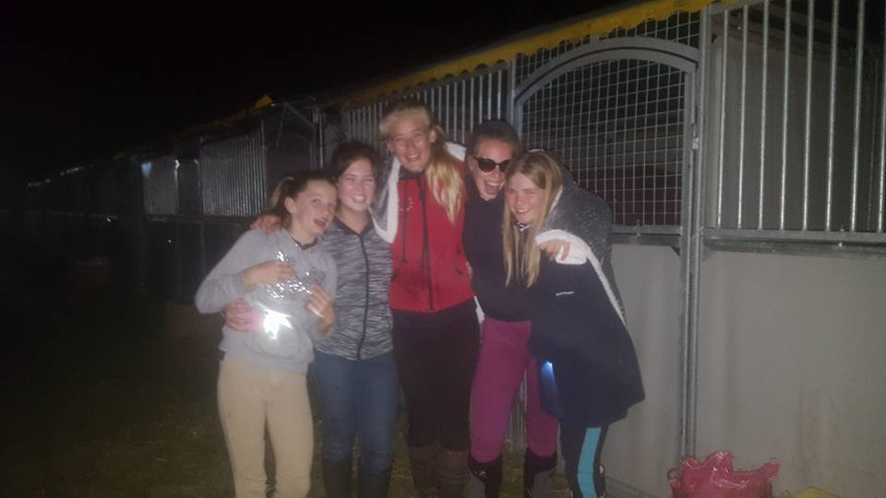
S South Wiltshire Riding Club ltshire Riding Club
Louisa Lockwood Clinic
Martine has been very busy this year organising some fabulous events and the clinic with Louisa Lockwood on Sunday 30th July was no exception. This clinic was held at Teffont and was open to members and non -members. Louisa is a very experienced local Event rider and an excellent instructor. The lucky people who attended her clinic had instruction in flat work and jumping and all came away saying what a fantastic day they had and are looking forward to the next one. No pressure Martine!
Clothing
We are adding new lines all the time, coming soon are baseball caps to wear when not wearing your riding hat! Keep checking the website which has photos of everything you can order with an order form. Ordering is usually every couple of months or when we have enough people to put in an order.
www.southwiltsridingclub.org.uk

W South Wiltshire Riding Club iltshire Riding Club
Dates for Your Diary
SWRC Winter SJ Qualifier and Clear Round at Downlands Equestrian
Oct 15th, Nov 19th, and Jan 21st.
Championship show will be 11th February 2018 at Dorset Showground
9th December Christmas Show at Manor Farm,Teffont

Thank you as always to our sponsors
KwM Galleries
SMS equestrian
Nadder Valley Equine
Equine Health and Wiltshire Life
AJC Drainage Ltd
Agricultural Water Engineers

Committee Members 2017
Chairman Donna Boyd 01380 488255 donnaboyd1@sky.com
Treasurer Janice Mitchell 01722 714342 jembobuk@aol.com
Secretary/Team Entries Janice Mitchell 01722 714342 jembobuk@aol.com
Training/Membership Sarah Mitchell-Sheppard 07843603147 sarah@smsequestrian.co.uk
First Aider/CPO Sarah M-S 07843603147 sarah@smsequestrian.co.uk
Publicity Laura Roberts 01747 871367 deadtreeuk@aol.com
Newsletter/website Sheri Start 07986 604564 sheristart@hotmail.co.uk
Instruction/Admin Alice Stone 07803 000057 alice.stone6@icloud.com
New Members Alex Hubbard 07733 230272 allyplank@hotmail.com
Martine Kemmish 07916 255268 martine.power@btinternet.com
Jessica Gibbons 01747 863448 jchgibbons1@gmail.com

www.southwiltsridingclub.org.uk

South Wiltshire Riding Club

Ride Together ~ Train Together ~ Compete Together ~ Have Fun Together

